**EVENT TRACKING IN ASP.NET**

**PROGRAM**

Public Class WebForm1

Inherits System.Web.UI.Page

Protected Sub Page_Load(ByVal sender As Object, ByVal e As System.EventArgs) Handles Me.Load

ListBox1.Items.Add("<<page loaded>>")

End Sub

Public Sub EventTracked(ByVal sender As Object, ByVal e As System.EventArgs) Handles Button1.Click, CheckBox1.CheckedChanged, CheckBox2.CheckedChanged, RadioButton1.CheckedChanged, RadioButton2.CheckedChanged, TextBox1.TextChanged

Dim t As String = CType(sender, Control).ID

ListBox1.Items.Add("<" & t & "> EventTriggered")

End Sub

Private Sub WebForm1_PreRender(sender As Object, e As EventArgs) Handles Me.PreRender

ListBox1.Items.Add("<page reentered>")

End Sub

End Class

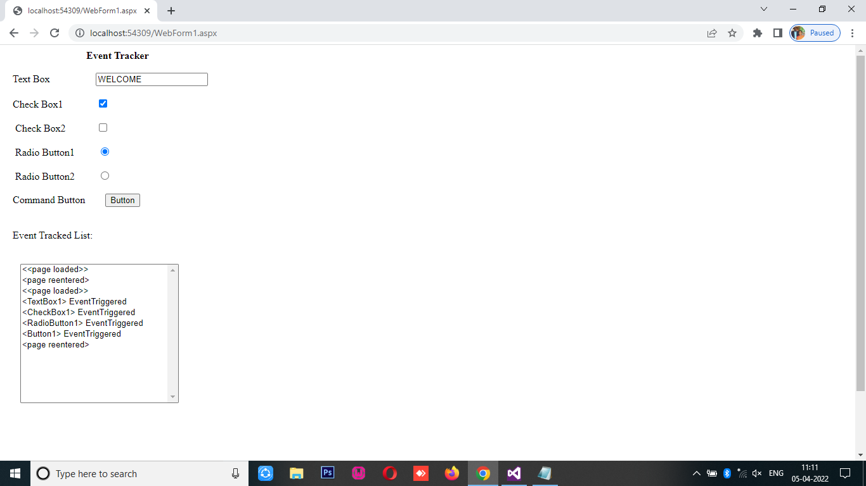**OUTPUT**